Frequently
Asked Questions (FAQ)
Artificial Intelligence
for Beginners

Introduction
This document answers frequently asked questions about Artificial Intelligence (AI). It is designed to help beginners understand common AI concepts, terminology, and learning paths through clear, accurate, and concise explanations.

Intended Audience
This FAQ is intended for:
- Students
- Beginners in Artificial Intelligence
- Technical writing learners
- Python learners
- Anyone curious about AI

TW-006

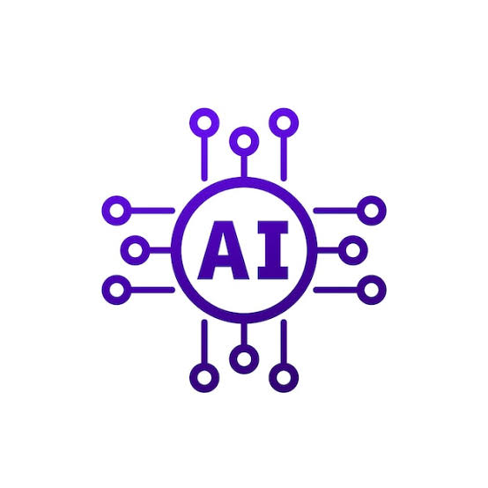

Document ID
TW-006

Author
Swetha
Date
10-07-2026





Frequently Asked Questions

Q1. What is Artificial Intelligence (AI)?
v


Artificial Intelligence (AI) is the simulation of human intelligence by computer systems. AI enables machines to perform tasks such as learning, reasoning, problem-solving, language understanding, and decision-making.

Q2. What is Machine Learning?

Machine Learning (ML) is a branch of Artificial Intelligence that enables systems to learn from data and improve their performance without being explicitly programmed for every task.

Q3. What is Deep Learning?

Deep Learning is a subset of Machine Learning that uses neural networks with multiple layers to recognize patterns in large amounts of data. It is widely used in image recognition, speech processing, and natural language processing.

Frequently Asked Questions (Continued)

Q4. Is AI replacing human jobs?

Artificial Intelligence automates repetitive and data-driven tasks, but it also creates new career opportunities. In many industries, AI is designed to assist professionals rather than completely replace them.

Q5. Do I need programming to learn AI?

Basic programming knowledge, especially Python, is recommended. However, beginners can first understand AI concepts before learning to build AI applications through coding.

Q6. Which programming language is most commonly used for AI?

Python is the most popular programming language for Artificial Intelligence because it is easy to learn and offers powerful libraries such as TensorFlow, PyTorch, Scikit-learn, and Keras.

Frequently Asked Questions (Continued)

Q7. Is mathematics necessary for AI?

Yes. Basic mathematics, including algebra, probability, statistics, and linear algebra, helps in understanding AI and machine learning algorithms. Beginners can gradually learn these topics while building practical skills.

Q8. What is Generative AI?

Generative AI is a type of Artificial Intelligence that creates new content such as text, images, videos, music, and computer code by learning patterns from existing data. Examples include AI chatbots and image generation tools.

Q9. Is ChatGPT an example of AI?

Yes. ChatGPT is an example of Generative AI that uses a Large Language Model (LLM) to understand user prompts and generate human-like responses for conversations, writing assistance, coding, and learning.

Frequently Asked Questions (Continued)

Q10. How can beginners start learning AI?

Beginners can start by learning Python programming, understanding machine learning fundamentals, practicing with Google Colab, building small AI projects, and exploring reliable learning resources to strengthen their skills.


Quick Tip : Focus on understanding AI concepts first. As your confidence grows, gradually explore programming, mathematics, and hands-on projects. Consistent practice is more valuable than trying to learn everything at once.

Best Practices
Learn AI concepts before advanced algorithms.
- Practice programming regularly.
- Build small projects to apply your knowledge.
- Stay updated with the latest AI technologies.
- Follow ethical AI principles when creating AI solutions.
Summary
Artificial Intelligence is one of the fastest-growing fields in technology. By learning the fundamentals, practicing consistently, and building real-world projects, beginners can develop a strong foundation for careers in AI, machine learning, and data science.
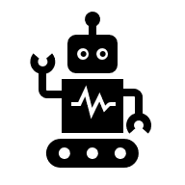
Note : The field of Artificial Intelligence evolves rapidly. Continue learning, experimenting, and improving your skills by using trusted resources and practicing with real-world projects.

